Pattern Cutting as Societal Manifest: the pioneering case of Contour Cutting

Ulla Ræbild
Design School Kolding, Denmark
ur@dskd.dk

Structured Abstract
Purpose: The paper sheds light on an almost unknown pioneer in fashion. The case of Preben Hartmann is the tale of a craftsman who, formed by years of training in traditional tailoring and haute couture during the 1950s and 1960s, opens shop and studio in Copenhagen in 1970 in the midst of the youth revolution. From his work with bespoke designs for costumers Hartmann develops the Contour Cutting system and thinking. A shape making system that is based on values such as user involvement, craft, creativity, body and beauty diversity, citizen resilience and designer autonomy.
The purpose of the study is first, to understand if, and possibly in what ways, the Contour Cutting System and the thinking behind it pre-empted current movements in fashion design practice related to pattern cutting and shape making with emphasis on overlapping issues such as creativity, waste reduction, body mobility, production and aesthetics , and as such pre-empted topics within the larger discourse on fashion design for sustainability. Second, as the Contour Cutting System is largely unrecognized, to discuss the relevance of the systems’ agenda for today’s acute challenges in the fashion sector and beyond. In other words, to examine in what ways Hartmann’s past thinking, may, or may not, inspire us in the present to re-shape the future of fashion design in terms of clothes and cultures of making.

Design/methodology/approach: The paper is constructed as a case study of the Contour Cutting System. The empirical material consists of a series of articles written by Hartmann for the Danish journal named Husflid (meaning craft or home industry) in 1985 in which Hartmann describes and illustrates the Contour Cutting pattern making system and the thinking. The case study sets the premise, to read the article collection as a manifest, in that they convey manifest traits, that is, a written statement declaring publicly the intentions, motives, or views of its issuer. Following introduction and background, the paper provides an account of Preben Hartmann’s life and career based on an extensive Curriculum Vitae written by Hartmann in 1991. It then analyses the Contour Cutting pattern system and manifest (CCSM) followed by a discussion of CCSM in relation to contemporary creative pattern cutting systems. Finally, the paper address CCSM through the perspective of recent fashion design manifests and use this to discuss key elements of the CCSM against current discourses in fashion design for sustainability.

Findings: Through examination of the Contour Cutting case, the study uncovers eight key themes embedded in the Contour Cutting system and thinking: Personal agency, Responsibility, Value of clothes, Fashion system critique, Body address, Health and well-being, Fit and (physical) freedom, Common good - common freedom. Moreover, the case study unfolds how pattern cutting and societal agenda has been linked in fashion design early in the rise of the sustainability discourse and prior to the critique of fast fashion.

Research limitations/implications: Due to limitations in paper length, only two pattern cutting systems where included in the discussion.

Practical implications: It has not been possible to access the Hartmann collection at the Danish Design Museum at the time of the study, due to Museum renovation and temporarily closing of archives. This has limited the empirical material in terms of photographic material and garments.

Originality/value: Through examination and discussion of the Contour Cutting case the paper contributes with new knowledge for research and practice on how an alternative approach to 3D shaping and pattern cutting occurred with Contour Cutting in the 1960’s. Based on the insights, the paper argues that fashion design making and pattern cutting, as exemplified in the CCSM, holds a potential for social engagement and critical consumption awareness, that it is timely to activate in light of the current fashion system break down, as a way to make fashion relevant in the future.

Keywords: Pattern cutting, designer autonomy, fashion pioneer, craft, fashion social agency, design manifest, fit, made-to-measure, sustainability, slow fashion

ISBN: 978-989-54263-1-7

Introduction
Our clothes follow us through life. Should they decide on us? On our freedom of movement? I guess we are free human beings, or are we? What are we free to do? I believe, we have our full freedom to take care of our bodies and our surroundings. Our nature, our country, our Earth (Hartmann, 1985).

This paper sheds light on an almost unknown pioneer in fashion. The case of Preben Hartmann is the tale of a craftsman, who, formed by years of training in traditional tailoring and haute couture during the 1950s and 1960s, opens shop and studio in Copenhagen in 1970 in the midst of the youth revolution. From his work with bespoke designs for costumers Hartmann develops the contour cutting system and thinking. A shape making system that is based on values such as user involvement, craft, creativity, body and beauty diversity, citizen resilience and designer autonomy.
Based in Hartmann’s Contour Cutting systems manifest (CCSM) (Hartmann, 1985), the purpose of the study is to examine interrelations and dynamics between pattern cutting, fashion designer autonomy and societal agenda. The overall aim is first, to understand if, and possibly in what ways, CCSM pre-empted current movements in fashion design practice related to pattern cutting and shape making with emphasis on overlapping issues such as creativity, waste reduction, body mobility, production and aesthetics , and as such pre-empted topics within the larger discourse on fashion design for sustainability. Second, as CCSM is largely unrecognized, to discuss the relevance of the manifest’s agenda for today’s acute challenges in the fashion sector and beyond. In other words, to examine in what ways Hartmann’s past thinking, may, or may not, inspire us in the present to re-shape the future of fashion design in terms of clothes and cultures of making.
Through examination and discussion of the Contour Cutting case the paper contributes with new knowledge for research and practice on how pattern cutting, fashion design autonomy and societal agenda has been linked in fashion design very early in the rise of the sustainability discourse and prior to the critique of fast fashion. Furthermore, based on the insights the paper argues that fashion design making holds a potential for societal engagement, that it is timely to activate in light of the current fashion system break down, as a way to make fashion relevant in the future.

Background
The steady increase of production outsourcing and the rise of fast fashion has to a large extend separated the fashioner designer from the making process. Hence, the process of designing has predominately become a computerized practice of sketching technical production drawings. This development has removed the designer from the tangible and sensorial interaction with fabric, body and three-dimensional shape. As a consequence, the designer is separated from a key creative and artistic source of inspiration for design development (Almond, 2010, 2016). Some designers and scholars have begun to articulate the negative impact of the dichotomized design process and argue for designers reclaiming the making aspect of fashion (McQuillan et al., 2013). Also, pattern cutting has been shown to address sustainability right from the core of the design process, as for instance seen in the zero-waste approach (McQuillan et al., 2018). Designers have furthermore been reclaiming pattern cutting as entrance point for creative development (Roberts, 2013; McKinney et al. 2016) as well as new theory of fit and well-being based on the body has been developed (Lindqvist, 2016).
A long the same line, manifest like texts have been formulated to raise debate on the purpose of fashion: who is value generated for and who’s needs are meet? These texts address on a bigger scale what fashion could or should become in light of climate change, pollution, species extinction (Fletcher et al., 2019; Rissanen, 2018), and de-growth (Fletcher and Tham, 2019). Looking for alternative actions and ways of making in design more broadly, we find the Agents of Alternatives: Redesigning Our Realities anthology offering a multitude of voices in what can be addressed as a co-created manifest (Fuad-Luke et al., 2015).
Lastly, the paper looks to the discourse on slow design in fashion for sustainability in combination with user-involvement and customization, as these practices relate to the case examined here (Clark, 2008; Gwilt, 2014; Gwilt and Rissanen, 2009).
Hence, the case study is positioned between the topics of a) alternative ways of pattern cutting and designer autonomy that has emerged and grown in the past decades, b) design-oriented manifest-like texts particularly in the light of the current fashion system crisis and c) fashion design for sustainability, in particular slow fashion.

Methodology
The paper is constructed as a case study (Crouch and Pearce, 2012) of the Contour Cutting System developed in 1968 by Danish designer and craftsman Preben Hartmann (1939 -1995). The empirical material consists of a series of articles written by Hartmann for the Danish journal named Husflid (meaning craft or home industry) in 1985 in which Hartmann describes and illustrates the Contour Cutting pattern making system and the thinking behind it (Hartmann, 1985). Hartmann does not call the articles a manifest. However, as the articles not only describe a pattern cutting technique, but are permeated with statements, opinions and declarations, the case study sets the premise, to read the article collection as a manifest, in that they convey manifest traits, that is ‘a written statement declaring publicly the intentions, motives, or views of its issuer’ (Meriam-Webster, 2020). The article series is originally written in Danish. Excerpts used in this text have been translated in to English by the author throughout. However, the issue and page references in text, refer to the original Danish version.
Following introduction and theoretical background, the paper describes Hartmann’s life and career. The section is an account reconstructed from an extensive Curriculum Vitae (Hartmann, 1991).
The study then analyses the CCSM. This analysis falls in two part: Technique contains an account of how the contour cutting system is conducted, as it is described in the CCSM. This works as a backdrop for the part named Manifested ideas, which identifies intentions, motives, and views embedded in the Contour Cutting Systems Manifest.
Insights from the analysis are then carried in to a discussion. The discussion addresses in what ways, CCSM align with, oppose or pre-empt current movements in pattern cutting and shape making with emphasis on for example creativity, body mobility, health, user inclusion and aesthetics. Recent literature on contemporary pattern cutting systems Subtraction Cutting (Roberts, 2008) and Kinetic Garment Construction (Lindqvist, 2015, 2016) is utilised for the purpose.
The discussion also addresses CCSM through the perspective of design manifests such as Possibility in Fashion Design Education - A manifesto (Rissanen, 2017) and Agents of Alternatives - Redesigning Our Realities (Fuad Luke, 2015) and use this to position key elements of the CCSM against current discourses in fashion design for sustainability. The paper finalises by a short conclusion.

Preben Hartmann - life and work
Preben Hartmann was born in Copenhagen in 1939. After finishing middle school in 1953 he completed in 1957 a five-year education in men’s tailoring (a combination of apprenticeship and school) at the then esteemed Copenhagen Department Store ‘Illum’. This was followed by a one-year specialisation in Haut- d´couture and theatre costume at Uffe Brydegård (1901-1962), a Danish dress maker and couturier who, apart from evening wear and women’s suits, also designed for films and theatre from his Copenhagen salon. As Hartmann mentions himself in the articles, he then struggles to find work in the field, and makes a livelihood as chauffeur for a couple of years, while beginning to follow courses on transcendental meditation.
In 1961 Hartmann is employed as professional couturier and model-maker back at the Brydegård salon, leading to a two year stretch at Danish high-end Fur House Birger Christensen, developing and processing model designs. In 1964, aged 25, the CV reports a move to Paris, France. There he achieves a diploma in pattern cutting from Chambre Syndicale de la Couture Parisienne. The duration of the education is unclear, but the same year he is then promoted at Birger Christensen to conduct fittings and oversee the development of model design for the international fashion showings. There is no clear account of whether he stays at Birger Christensen in the years 1964-1967.

However, in 1967, aged 28, Hartmann enrols in a business and PR education in Bergen, Norway and works thereafter as an accountant for an accountant company in Copenhagen from 1968. Meanwhile, also in 1968, he develops the Contour Cutting system (in Danish named Anatomical Pattern Cutting). The following year, 1969, Hartman formally registers ‘Purple Heart’ as the name for his own shop with accompanying workshops for development and production of ‘…Leather wear, Fur, Leather footwear, Bags and Belts, as well as Jewellery and Buckles in precious metals, with clients from all over the world’ (Hartmann, 1991)
(figure 1).
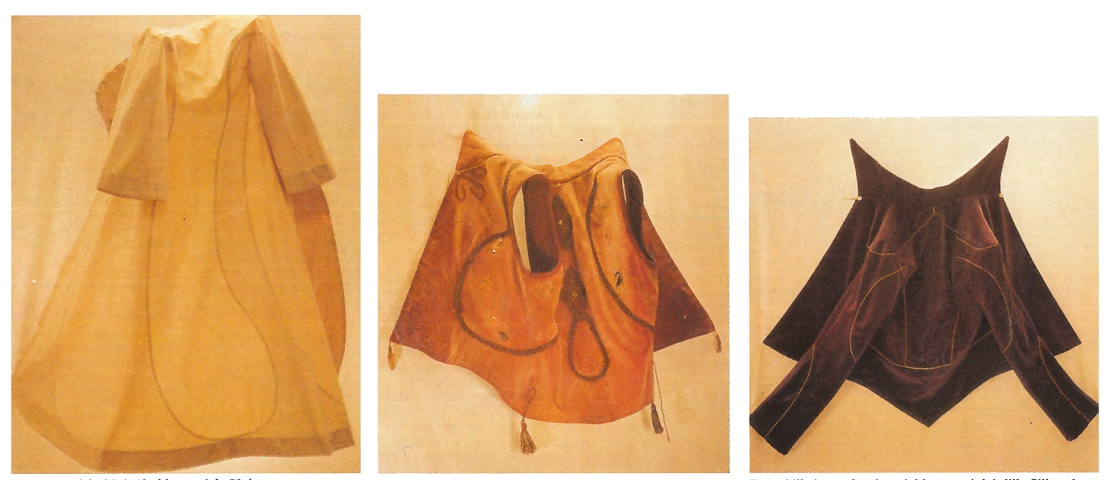
Figure 1. Coat, vest and jacket models showing turning cut variations using Contour Cutting. Hartmann, 1985.

The CV shows, that Hartmann in 1971 pursues an interest in yoga and meditation at the Gyllingnæs Ashrama in Jutland Denmark. 1972 sees some expansion of activities. Hartmann tests whether some of his contour cutting model designs may be suitable for a serial production, at a ready-to-wear production facility in Silkeborg, Denmark. However, there is no mentioning of the results. He also registers the Purple Heart business name in Sweden and Switzerland and opens a shop in Stockholm selling his own products, while refurbishing the Copenhagen shop. Furthermore, he begins to explore and develop Contour Cutting (here also named Functional Form giving) to encompass architecture, furniture and household items, which he supports by studying architecture and science at the anthroposophical centre Goetheanum (designed by Rudolf Steiner) in Switzerland in 1973, while also making study trips to Austria, Germany and France.

At the age of 35, Hartmann travels to Australia in 1974. Again, he formally registers the Purple Heart name and seems to become very active very quickly in the Brisbane community. According to the CV, he joins a group of designers, furniture manufacturers, engineers and architects, called the 4-D Design Group. He exhibits ‘new textile design’ for the Ministry of Culture and industry actors. He teaches Contour Cutting to educators at the Kelvin-Grove teachers’ college. Instructive videos are produced to aid dissemination in the school system. He takes part in the Craft Association of Queensland exhibit of fashion and garments at the State Gallery and are interviewed for a radio show on his ‘design and life-world view’. The garment exhibit is followed by yet an exhibit about ‘Alternative ways of Building directly in to the landscape 1:10´, which leads to further radio interviews and invitations for lectures. After taking two courses in ceramics and teaching pedagogics, the Australian activities seem to stop for a while. 1975 records travels for yoga training in India, and craft study trips in Indonesia, financially supported by teaching evening classes for teachers in Denmark for the Copenhagen Municipality. All of 1976 records teaching activities around Denmark and the year ends by Hartmann closing down the Purple Heart shop in Copenhagen. Between 1977 - 1982 he travels back and forth between Australia and Denmark, teaching teachers and layman, exhibiting and generally disseminating the Contour Cutting System.

In 1982, now at the age of 43, Hartmann more permanently relocates to Denmark and sets up studio in the centre of Copenhagen. From 1982 - 1985 he has a double practice. He makes custom made designs, primarily for the Scandinavian upper classes. And then he does extensive teaching in private courses for groups, as well as for institutions, where he cultivates the dissemination of Contour Cutting in a wide setting such as for ‘alternatives leaders’ at Rudolf Steiner, the Gay community around the Copenhagen night club ‘Pan’, crafts communities, ‘entrepreneurs for discipline critical activities’, craft teachers and conventional educations of handiwork. Following these activities, he is invited to write the series of articles about the Contour Cutting System for the Danish craft Journal ‘Husflid’ in 1985 (Hartmann, 1985) on which this study builds. He then reports packing all his possessions to return to Australia.
However, in 1986, Hartmann teaches at ‘the Danish Højskole Kerteminde’ a school specializing in crafts and handicrafts in the small town of Kerteminde situated on the eastern part of the Funen Island. (‘Højskole’ was, and is, a type of after education for adults where you live at the location. Often 6-12 months). Following, Hartmann is employed in a full-time position, to teach Contour Cutting at the after-education programs, as well as in the School’s formal teacher training education. He buys a farm property and settles in Revninge, a tiny village outside Kerteminde, with the intention to develop and host both product production and course activities. 1987 sees some disagreement over contract between Hartmann and the Kerteminde School as well as Hartman note down issues with teacher terms in general. The conflict leads to the dismissal of Hartmann after only one year of employment.

Hartmann stays on living and working in Revninge and from 1987 to 1991 the CV shows a broad involvement in the local community. He sets up a Contour Cutting school at the farm, but is instructed by the local council to close it down (Hartmann offers no further explanation on the matter). However, he takes interns and teaches in other contexts, gives lectures and partakes in the local and regional theater groups as costumier, exhibits in local and regional public spaces and engages as board member for the local riding club, the local youth club and the Danish Nature Preservation Organisation. The CV is written in 1991 and does for this reason not cover the years from 1991 to Hartmann´s death in 1995, aged 56.

What is the Contour Cutting system and thinking about?
The analysis is divided in two. First, the contour cutting system technique itself is deciphered based on Hartmann’s descriptions in the articles. Thus, it looks into procedures and tools, preparations and uses as well as executer and receiver. The illustrations inserted as figures all originate from the article series as they were sketched and photographed by Hartmann. Second, the articles are analysed in terms of manifested ideas, that is ‘the intentions, motives, or views of its issuer’ that may be identified in Hartmann´s text. Throughout the analysis, the in text citations from the article series are referenced as: (issue no/page), as they are all same year and author (Hartmann, 1985).

The Contour Cutting Technique
What shall we do? What shall we make? How shall we make it? But foremost – Why? Here I will tell a bit about why I make something, and also a little bit about – how (Hartmann, 1985)

In Contour Cutting, the piece under development is called a model (model is therefore not a term used to name a human model). The model is modelled in generic brown paper of the sort used to wrap parcels and comes in large rolls. This type of paper is smooth and shiny on one side and mat on the other. Apart from brown paper, one needs generic transparent cello tape (and preferable a tape holder, so you only need one hand to take a piece of tape), a pair of paper scissors, a pen, a table with corners and a small ruler or stick.
The model is always modelled directly on the person who is to use the final garment.
Thus, the modelling process takes place while both the model maker and the model user are present together. As a general rule, the model is always made on the right side of the person’s body and the model is made with the shiny side of the paper facing outwards. These guidelines help to identify left and right on the pattern pieces after cutting up the model. The person is to wear a relatively tight-fitting T-shirt under the model, for a base model. For overgarments, one is to wear the type of garment while the model is been modelled, that one wishes to be able to fit underneath the overgarment when in use. For example, a sweater (fig. 2).
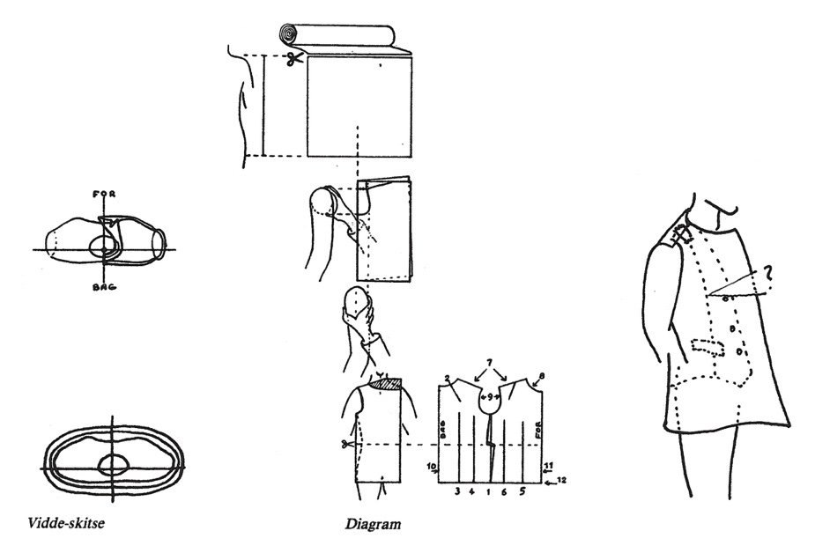
Figure 2. Illustrations for beginning modelling a base model. Hartmann, 1985.

In the articles, Hartmann describes and illustrates the process for a number of different types of garments. He begins with a base model, which is a torso model that sits close to the body from the neck and down below the widest place on the hip. The principles introduced for the base model, are the same for all the garment types, with small variations. The notion of fit is stressed: ‘The most important part of our clothes is the fit (…) we will bring out the completely individual fit´ 2:42). For Hartmann this means:

(…) neck hole, in the right place, our curve of the back - at the top – the shoulder fall – the right placement of the arm hole on the side - the bust where it belongs - waist height down from the waist (note that women’s waist lies higher up at the front than at the back! Men are just the opposite) - the curve of the hip - and - if one is round or flat behind and so forth (ibid.)

This detailed description of fit variations, emphasizes the relevance for individual fit embedded in the contour cutting technique. After cutting a preliminary arm hole (measures are taken, not by using ruler or measurement tape, but by hand), the model is folded around the body and taped at the shoulder. Then folds are made in a specific order, by which paper is folded away as incisions, which makes the model follow the shape of the body. We need, in Hartmann´s words ´to fold the surplus, - from the cylinder, and in towards the body – away, in the places where we have our shapes´ (1:15).
These folds are taped down flat. Directions are given in terms of making neck hole, arm hole, front and back center and length from floor. Contour Cutting is thus a technique whereby shapes are made in an un-stretchable, yet foldable, material (paper). In this way, shape is made through a number of high points and low points on the body. As explained in the articles, this provide freedom and choice when cut lines are to be decided considering the user´s individual shape and taste. Cut lines must somehow go through or address the high and low points, but as the shapes consist of planes directed by points, there are no predefined curves (as for example a curve on the upper side seam) to be followed. Hartmann writes that ‘the body is like a landscape with hills and valleys. To know the true ground area, we have to know these hills and valleys - they have to be made flat!’ (5:126). This is illustrated by Hartmann through cutline variations of a jacket model (Figures 3-8).
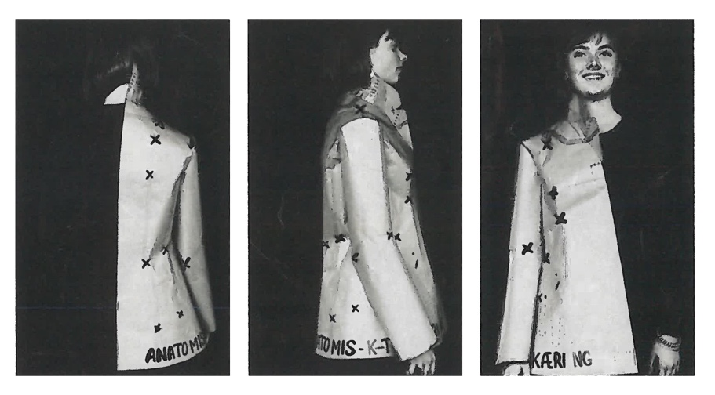
Figure 3. Jacket model in paper with high and low points marked with crosses, Hartmann 1985.
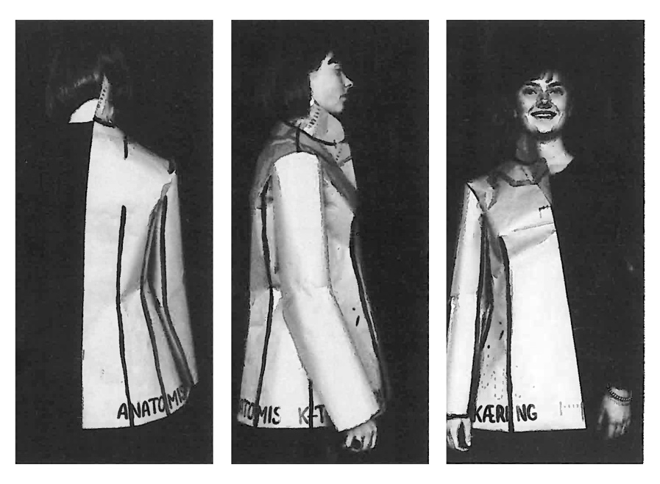
Figure 4. Jacket model in paper with traditional cut lines, variation A, Hartmann 1985.

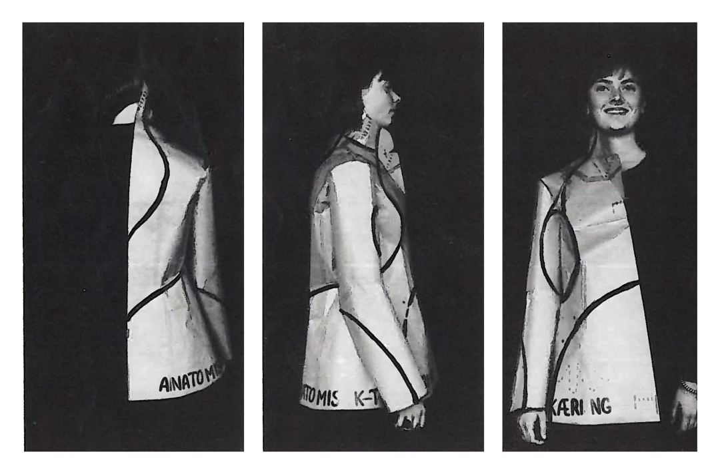
Figure 5. Jacket model in paper with Contour Cutting turning cut lines, variation B, Hartmann 1985.

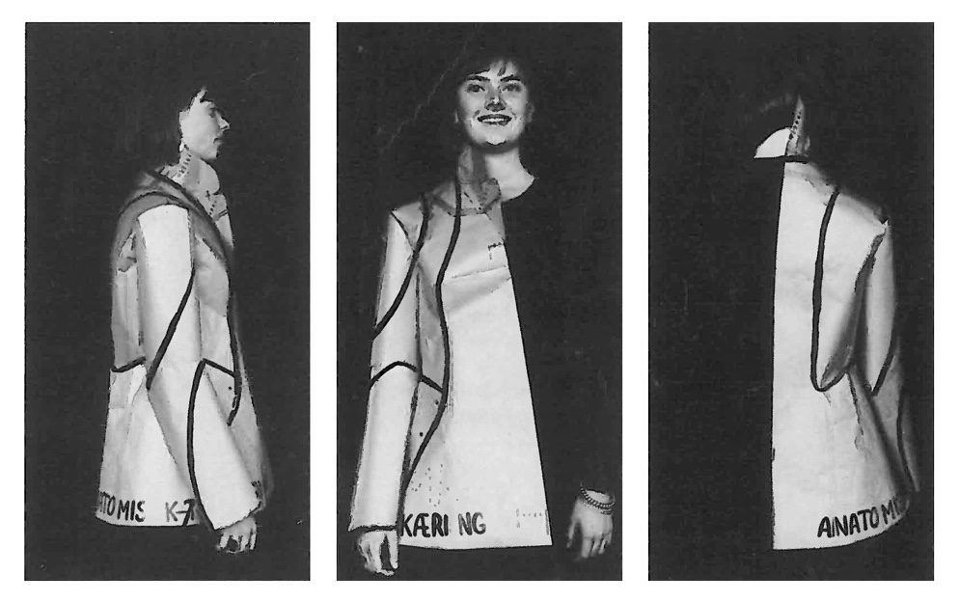
Figure 6. Jacket model in paper with Contour Cutting turning cut lines, variation C, Hartmann 1985.

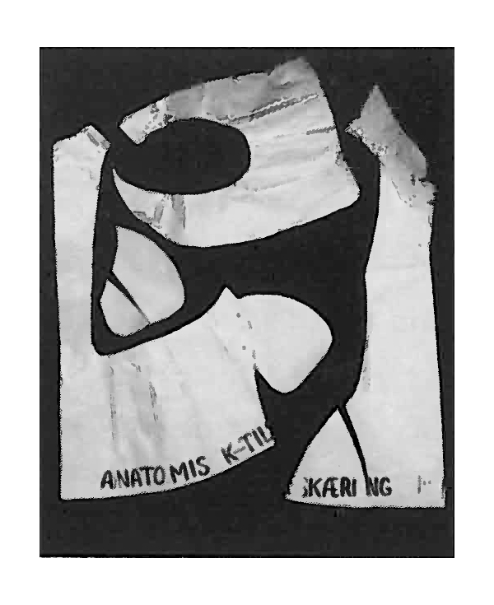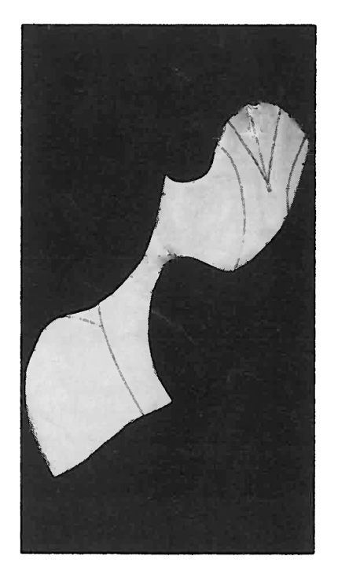
Figure 6 and 7. Jacket model in paper, variation C cut open and placed flat. Torso left. Sleeve right. Hartmann 1985.

After introducing to the base model modelling procedure, Hartmann exemplifies in the article series how to model jackets, collars, shirts, dresses, skirts, bras and trousers. Always in the brown paper and always directly on the persons body 1:1. According to Hartmann, this technique saves rounds of fitting:

With this new fitting system, we work more than 10 times as fast as otherwise and completely without stress. If we humans shall keep up with the technological development, we can’t sit around and fiddle with stuff that has no use at all. Hence this new procedure, that doesn’t have to be tried out along the way, but fits perfectly every time (Hartmann, 1985, 1:14)

In short, the Contour Cutting system is about folding paper around the body (of the person who are wear the garment) 1:1 following a certain technique and order of folding. Shape and volume are created by either taking away or adding volume to the model while on the body, whereafter cutlines through high and low points are decided (also directly on the body) and the model cut out for pattern pieces to lie flat on fabric. As often in conventional flat construction, the material used is paper, however the modeling takes place on a real person´s body three dimensionally, and can in this way resemble draping.

Whilst Contour Cutting is described by Hartmann as an ‘ecological basic shape making system’, that is simple to use, also for layman, in the sense that it is easy to understand, fit-wise precise, time efficient and accessible in terms of required means and tools, the additional writing besides the technical explanations are elaborate and address many topics. This is addressed in the following section.

Manifested ideas in the Contour Cutting articles
A key issue, Hartmann returns to several times in his writing, is the idea of responsibility. We are responsible, not only for the now, but for the effects of our actions in the long term. Thus, as he states: ‘the belief in a beautiful and dignified human life here on Earth, for ourselves and our descendants’ (1:14). However, he pulls in the focus, and links the holistic perspective to how we dress ourselves, well aware that humans are, after all, not the center of the universe:

But let’s be a little selfish, even if we know that we are just a tiny part of the earth and the solar system. Yes, an almost insignificant piece of fluff in the time and space of the universe. Let us then believe, that it is us humans, that it all revolves around, even if we live for such a short time. Let us see ourselves as the center, and shape everything that surrounds us, after our bodies and its needs (Hartmann, 1985, 1:14).

As in the quote above, Hartmann often write from an including ‘we’ narrator perspective in the text and his way of linking what we wear with how we live, what we think and how we act permeates the writing. This section presents Hartmann´s manifested intentions, motives, and views, as identified in the article series. The analysis has surfaced eight key themes exemplified through excerpted citations (issue/page) below:

- Why do anything? Personal agency
- Responsibility
- Value of clothes
- Fashion system critique
- Body address
- Health and well-being
- Fit and (physical) freedom
- Common good, common freedom

Why do anything? Personal agency
Hartmann begins the article series by asking the questions: ‘What shall we do? Shall we do anything at all?’ (1.14) and thereby invite readers to engage in and commit to a personal reflection in the context of clothes making, on what and why we actually do what we do. Furthermore, he explains how, for him, experimentation in general, as well as critical assessment of other people’s experiences, are necessary life approaches. As he reflects ‘…then your life begins by living on other people’s experiences, or their lack of same. Maybe you don’t experiment so much. I do nothing but’ (ibid.). Hartmann shares his sense of urgency, when asking the question ‘what shall we do?’ His ideas of doing things differently began in the sixties, but stresses that ‘…then it was about having a free space – now it is life itself on the line’ (ibid.), thus moving agency from a youth movement to a common agenda of pending climate and environmental disaster - life itself.

Responsibility
Personal responsibility is, as mentioned earlier, an ongoing theme for Hartmann. In his opinion ‘…you can do with yourself, as you please, if you don’t destroy others and what they create, or what has been created for us all, what we come from, - nature – the earth we live on – this part of the universe’(1:14). In his view we must be willing to think about consequences of our actions, also on the individual level. We are all accountable for the Earth ‘which we here and now, and for all time, are responsible for’ (ibid). Hartmann ties together personal agency with personal responsibility as he emphasizes that ‘we are indeed responsible for our actions, and then we are back to our starting point. What shall we do? What shall we make? How shall we make it? But foremost – Why?’ (ibid).

Value of clothes
There is a detectable undercurrent of frustration in the writing, that Hartmann seems to have built up over many years. He observes: ‘In general, one thinks nothing much of clothes. Anyway, this is what you often hear people say: It is not the clothes that are important’ (2:42). He goes on to ask: ‘So, what is it, that makes us disregard clothes in daily life? After all, we do nothing but try to be able to be in fashion, to show ourselves to each other’(ibid.). Hartmann sees the power that the fashion system holds over us, while contradictory, we deny the fact that clothes matter. However, for Hartmann, the value of clothes appears to lie elsewhere than performing as consumers in the fashion system, as he exemplifies when speaking about a basic shaped shirt garment: ‘It is inspired by our old simple peasant shirts, and Indian shirts (oriental coats) - the stone age people´s clothes. Beginning of human civilization, lifeform and needs´ (6:156). He uses this example to connect knowledge, and thereby value, from past to present: ‘We all know it, but unfortunately doesn’t take it seriously enough, as it is only clothes - but remember! It is basic clothes! it is our roots, our ancestors’ clothes - it is heritage, and it is the foundation we live upon (ibid.). Hartmann thus also poses a critique of our way of forgetting (valuable) practices of the past, in particular in the making of garments.

Fashion system critique
Hartmann weaves in a fair amount of fashion system critique, in the sense that he believes in individual beaty and everybody’s autonomous right to decide for one self: ´Who decides the fashion? WE do! It is of no use, wishing to look like some empty idol. We have to look like ourselves - as we are! Because without this, we will never become anything! (3:74). Hence, to Hartmann, looking like ourselves is tied to becoming ourselves. He comments on the urge to blend in and asks: ‘Could it be, that we perhaps spend too much time on hiding our ´flaws´- our personality - hide ourselves in the masses - be like everybody else? Save yourself the trouble - you are unique - we all are - LUCKILY!’ (3:73). In this way, his strong believe in the individual uniqueness mirrors the Contour Cutting technique. However, being yourself takes courage and energy, yet in Hartmann’s opinion ‘we cannot in the long run endure being someone else than we are, just because it is in fashion’ (3:74) and points out the null-sum game inherent in the fashion system: ‘when we finally have become, what fashion “demands”, and have spent our last nickel, and are happy for one single day, THEN the fashion changes, and we are back at square one - has become unfashionable again. So, forget it!’ (ibid.). Hartmann suggests instead to be yourself, because ´If you are yourself, you will never be out of fashion. You just change very slowly through life in harmony with your own development’ (ibid.). Hartmann asks the obvious question ‘but how to become oneself?’ His answer, and as replacement of fashion, is to work with individual fit, individual cutlines and individually shaped collars that reflects our individual body shapes and in particular ‘the area around our face. We shall try to bring about lines in our clothes, that emphasize our personality, not overrule it´(ibid.) (figure 8).

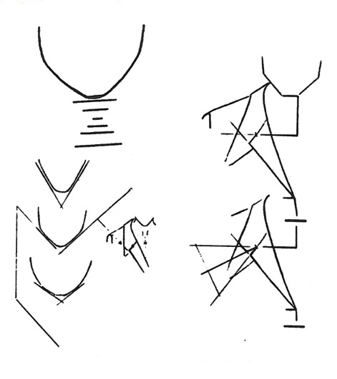
Figure 8. Shaping collar after face lines. Hartmann, 1985.

Body address
The Contour Cutting system, and thereby Hartmann’s approach to pattern making, places the individual body in the center of making. Key to the approach is the reasoning, that because ‘this form of pattern making is very precise, we can allow ourselves to cut the garments according to anatomy and the muscle lines in the body’ (1:17). Thus, the body itself, as form, influences (or can influence) the aesthetic language that follows from using the technique. Hartmann further embeds bodily movement as a parameter for shape making. As example he describes, that ‘when we walk, we move the head forwards and backwards, to follow the movements of the body. We create a kind of rocking balance, that makes it easier to walk. It happens completely automatic’ (3:74). In his view, ‘our body has overall many automat functions, and it is vital not to hinder those, that are absolute essential for our health’ (ibid.).
Another important factor, is to pay attention to how garments feel on our bodies. Thus, the process of modelling on a person, must include a dialogue with the person on preferences, based on what feels good. Hartmann exemplifies this when he describes options for closures in overgarments, and ‘whether one wish for a button hole, a tie string or something else. Imagine how it would feel, if one pulls back the arms - when the jacket is closed’ (3:72). Contour Cutting is thereby also about shaping and modelling garments with a focus on how clothes are experienced by the wearer, what feels comfortable. Lastly Hartmann put forward, that although paper models can be cut open as in traditional pattern making with side seams and darts, he finds that ‘turning cut do provide a better fit, and is pleasant to wear (6:155). He also finds that turning cuts ‘looks more natural, especially - if we choose slimming lines, that elegantly cling around our legs’ (6:155). Hartmann thereby claims, not only that contour cutting provide better physical comfort than traditional pattern cutting, but also, that because it is based on body lines and proportions, it is more natural and therefore more elegant (ibid.)

Health and well-being
Throughout the articles, Hartmann links together clothes with health and well-being. Three sub-themes emerge: choice of materials, tightness of clothes and body temperature. In terms of materials, he is a strong advocate for natural fibers and states: ‘If we are to have a more harmonic and natural future, then we need to shift to using natural products only in our clothing, so that people don’t get electric from static electricity in the garments’ (1:14). In his opinion, we can get ill from synthetic materials and finds for example that ‘people with rheumatism do not suffer synthetic fabrics well. Maybe we become rheumatic from synthetic fabrics!’ (1:14). Furthermore, he finds that synthetic fabrics are ill suited to help the body regulate its temperature (ibid.). However, body temperature can also be affected by clothes being too tight and describes cause and effects: ‘We freeze, we put on more clothes. It is too tight in the arm hole. This activates the sweat gland under the arms. We get wet from sweat, sweat becomes cold, we get different temperatures on our bodies, we become untimely, we sweat even more’ (1:14). Tightness in the wrong places can also bring other sufferings to the wearer. For example, if garments are too tight over the neck ‘it brings infiltrations and head ache. If it rests on the shoulders, it prevents the free movements of the arms, and ruins the back musculature’(ibid.). Hartmann also address how body movement affects the clothes we wear, which again affect our body temperature. For example, ‘we have to make sure, that there is room enough at the front, so that we can take our steps forward, without it opening at the bottom. Think about the draft that often, particularly in the winter, causes abdomen inflammation’ (3:73).

Fit and physical freedom
Staying with the topic of how clothes affect the body, another key theme is how fit influences on mobility and physical freedom. Hartmann begins the articles by acknowledging that ‘we who create the fashion, have a huge responsibility towards our fellow humans, and their ways of acting!’ (1:14). Physical freedom, as expressed in the text, can be of a low practical nature, such as balancing volume in a skirt so it doesn’t lock the legs together in movement. But it can also be of a more severe nature. Hartmann describes, in an elaborate section on how to model bras, the troubles many women experiences with bras. He finds, that because the bust is soft, it can be placed by bras in ways that are damaging to women’s health and a serious problem: ‘We want it to sit at the front, and not out at the sides (…). If we can move the arms freely back and forth, then we don’t tense in the neck muscles, leading to headaches’ (3:71). Similarly, he describes how to place shoulder straps to be able to ‘lift the arms without lifting the bust’ and how free movement of arms ‘gives us good balance, by being able to swing them when we walk - which again relieves our hips and legs’ (ibid.) (figure 9.). For Hartmann, it appears important to think comfort in to clothes fit, and to be able to emphatically address bodily needs.
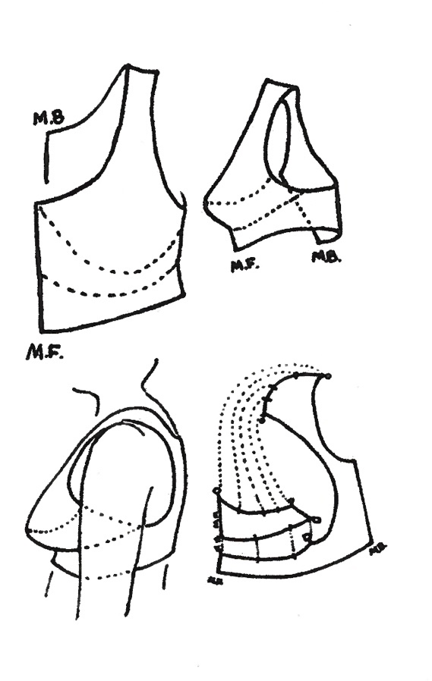
Figure 9. Bra. Hartmann, 1985.
Common good, common freedom
A key feature argued in the Contour Cutting system, is the possibility and freedom to place cut lines according to anatomy. However, Hartmann stresses that ‘the anatomical turning cuts, in line with copy right law, only can be used for private or personal models’ (5:126). By copyrighting the cut lines, Hartmann aims to secure the system as open source, for all to use. Furthermore, he emphasizes ‘that our true nature mustn’t be made object for speculation in fashion, so we one day end up with our anatomy being out of fashion’ (ibid.) It is thus also a matter of concern, to keep the anatomical cutlines protected from trend mechanisms. In Hartmann’s thinking, open source, nature, health and responsibility are matters that are held together in making: ‘What I want to see, is a natural health for free responsible people. Those who wish to fabricate after these cuts, may, as I, be a part of rectifying the damages that has happened under wrong fashions’ (ibid.). Thus, following Hartmann, if you engage with Contour Cutting, you also take upon you to engage responsibly in the world.
Whilst responsibility is a key theme, so is the notion of freedom. To Hartmann, they seem interdependent. He observes that ‘we have become so terribly dependent, of people we don’t even know at all’, and that ‘our world has become a stressed tangle of people rushing after things there are no need for, and that makes us ill’ (6:156). Hartmann views Contour Cutting as a way of making, that, in his view can be a way of making your life - a basic approach to life that provide us with freedom. He writes that: ‘If we allow ourselves the time to understand the significance of the Contour Cutting system and its purposes, we will only be dependent on ourselves, and our nearest, which is the absolute biggest freedom we can achieve, and it is real’ (6:156). Hartmann’s claim seems to suggest, that Contour Cutting provide a system of making, that when applied broadly in our lives, can make us independent from the consumer society.

Discussion
The analysis shows, that for Hartmann, Contour Cutting is bound to a worldview and has arisen from a worldview. If we look at Contour Cutting system in itself, as a way of making garment patterns, it is a system were there are practically no use of measurements and very few tools involved. This means, that making patterns together can be done practically everywhere. You just need paper, cello tape, scissors and a pen. Moreover, sizes are non-existent. The system thus offers a liberation from the size-regime imposed by conventional pattern making. There are some key principles, that should be followed, but otherwise Contour Cutting leaves room for individual preferences and creativity. In this way, everyone is given the opportunity to think about what they like, and what feels good - in dialogue between the model maker and the model user. This, however, can also be a challenge. With few guidelines to lean on as a maker (and user) in terms of placing of details, cut lines and silhouette, you have to trust your own eye and hand, especially since Hartmann advises not to use the practice of fittings and toiles. Contour Cutting has a high emphasis on cutting not only on the grain line, but utilises levels of bias for flexibility and comfort, as well as good fit. If turning cuts are used, the bias arises from the patterns themselves, when placed on the fabric. The system is made public available by Hartmann through the articles.
Many of these traits can be found in newer pattern cutting systems. As example, Free Cutting, also known as Subtraction Cutting coined and described by Julian Roberts (2013) also believes in open access, individual creativity and learning by doing as ‘there are not step by step guides or lessons! I want you to trip up and make your own mistakes’ (ibid. p. 1). As Hartmann, also Roberts sees that pattern cutting for garments can in fact be used at large in life for many purposes. Hartmann talks about houses in the articles, Robert suggests that Free Cutting ‘can be used to make women’s or men’s clothes, bags and millinery, or on a larger scale anything hollow such as a tent or a lampshade (ibid. p.12). Another commonality is to eliminate laborious, time consuming and unnecessary processes. Roberts calls it ‘to cut fast and inaccurately without too much reference to numbers, fractions or sizing scales’ (p.13). A big difference between the two systems, is that Subtraction Cutting does not take place on the body, the body enters the model after the cutting, whereby chance interactions between body, fabric and shape occur.
Another current proposal for pattern cutting is seen in the work of Rickard Lindqvist (2015, 2016). He proposes Kinetic Garment Construction as a theory and aim for ‘greater diversity of artistic expressions and enhanced functionality in garments’ as well as ‘a deeper consideration for the interaction between textile materials and the living body’(2016, p. 106). Thus, a focus on the living body. And, as we find it in Contour Cutting, also Lindquist find it important not to ‘restrain its movements’ (ibid p.108). Where Hartmann silently writes out the metric measurements and traditional tailoring methods, he has learned in the course of his extensive training, Lindquist is otherwise explicit. He finds that in ‘the tailoring method of cutting garments (…) the active, moving body is abstracted into a series of fixed, static numbers’ (ibid. p. 106). Similar to Contour Cutting, Kinetic Garment Construction looks at the human body physique, lines in skin and muscle, as outset for placing and cutting lines in the garment. However, where paper is used in Contour Cutting, Kinetic Garment Construction work with fabrics and drape on the live body.

If we turn to the intentions, motives, and views that Hartmann express in the articles, there are a number of themes that align with current movements in design for sustainability in fashion. The CCSM places clothes and clothes making outside a commercial market. Clothes is something we make for each other, on each other, and either sew ourselves, or make as bespoke at the most. In this way, Hartmann align with proposals for alternative ways of living with fashion, that are not linked to a commercial market and growth (Fletcher and Tham, 2019). Hartmann’s life trajectory shows, that he was engaged with the youth revolt, anthroposophy and eastern philosophy, and this may well have influenced his rethinking of fashion and pattern making practice. His complete eradication of sizing, further speaks in to the current body positivism movement. Hartmann aims to simplify cutting for laymen to gain access to making. Thus, a making agency that we also find in Hirscher’s (2015) project Make(able) which is ‘about the potential of joyful making, exploring, learning and creating together to engage and activate users to rethink their consumption patterns, encourage their agency and create greater well-being by consuming less’ (ibid p. 228). Hirscher and Hartmann both connect making abilities with critical consumption abilities. When Hirscher writes about ‘empowering citizens on how to construct garments’ and ‘enable stronger user-involvement in the design process’ (ibid.) there is a visibly strong resemblance. Originating from design, Hirscher uses a different vocabulary than Hartmann as she describes her work with ‘participatory design workshops and half-way garments (…) that allows a relocation of the roles between designer and consumer through collaborative making` (ibid.). However, in terms of fashion, they both strive for what Hirscher sees as ‘to offer alternatives to the mainstream, and thus create new moments of awareness and learning through alternative channels’ (p.236).
The CCSM has a strong focus on health and well-being, in terms of body temperature, muscle tension and balance. Health is not something that is often addressed in modern day fashion, unless we speak of chemical residues in garments. We find notions of health addressed by Rissanen (2018) as he ‘reimagines fashion design education as a site to conceive fashion as a system of satisfiers for fundamental human needs’ (p. 530), where needs include ‘subsistence, protection, affection, understanding, participation, recreation/leisure, creation, identity and freedom’ (ibid. p. 536). As Hartmann, Rissanen thus propose fashion as place and a practice that can encompass a rich array of human needs. As fashion users, we may be participants, we may be creative and our garments may offer the right protection. Education in terms of raising awareness of our clothes becomes an important factor, because, as Rissanen sees ‘aspects of fashion usership may verge on automatic, in that we barely consider them in our daily lives’ (ibid. p. 530). Thus speaking in to the paradoxical garment invisibility, that Hartmann points to. The CCSM was written as an educational text, to raise discussion on garment making and use, and to offer the technique for public use. Thus, to link the way we make and use clothes with the way we live overall. At a time prior to the internet, the system disappeared with the passing of its creator. However, the Contour Cutting system is relevant in itself as a 3D shape making technique that supplements other methods and offers its users creative possibilities and understandings. Based on the analysis and discussion, the author further argues, that the CCSM, as fashion critique and maker/making proposal, can be a voice that amplifies current discourses on how to foster change in the fashion industry for sustainability through our way of engaging with clothes in everyday lives.
Conclusion
The aim of the case study was to understand if, and possibly in what ways, CCSM pre-empted current movements in fashion design practice related to pattern cutting as well as topics within the larger discourse on fashion design for sustainability? Furthermore, to examine in what ways Hartmann’s past thinking may have relevance for society in the present when we speak of the future of fashion design in terms of clothes and cultures of making. Through examination and discussion of the Contour Cutting case the paper contributes with new knowledge for research and practice on how alternative approaches to 3D shaping and pattern cutting occurred with Contour Cutting in the 1960’s. Moreover, that fashion design autonomy and societal agenda has been linked in fashion design early in the rise of the sustainability discourse and prior to the critique of fast fashion. Lastly, based on the insights, the paper argues that fashion design making and pattern cutting, as exemplified in the CCSM, holds a potential for social engagement and critical consumption awareness , that it is timely to activate in light of the current fashion system break down, as a way to make fashion relevant in the future.

References
Almond, K. (2016), “The Status of Pattern Cutting”, Fashion Practice, Vol 8, pp. 168–180.
Almond, K. (2010), “Insufficient allure: the luxurious art and cost of creative pattern cutting”, International Journal of Fashion Design, Technology and Education Vol 3, pp. 15–24.
Clark, H. (2008), “SLOW + FASHION—an Oxymoron—or a Promise for the Future …?” Fashion Theory, Vol. 12, pp. 427–446.
Crouch, C, Pearce, J. (2012), Doing Research in Design, Berg, London
Fletcher, F., Tham, M. (2019), Earth Logic Fashion Action Research Plan, The JJ Charitable Trust, London,
Fletcher, K., Pierre, L.S., Tham, M. (Eds.) (2019), Design and Nature: A Partnership, Routledge, New York.
Fuad-Luke, A., Hirscher, A.-L., Moebus, K. (2015), Agents of Alternatives - Re-designing Our Realities”, available at: https://issuu.com/agentsofalternatives/docs/aoa_online_free_pdf (accessed 29. September 2020).
Gwilt, A. (2014), Fashion Design for Living. Routledge, London.
Gwilt, A., Rissanen, T. (2011) (Ed.) Shaping Sustainable Fashion: changing the way we make and use clothes, Earthscan, London.
Hartmann, P. (1985), ”Anatomisk Tilskæring”, Husflid no. 1-6, Odense, Dansk Husflidsselskab
Hartmann, P. (1991), Curriculum Vitae. Private document from Hartmann estate.
Hirscher, A.L. (2015), “The Joyful Experience of Making Together”, in Fuad-Luke, A., Hirscher, A.-L., Moebus, K. (Ed.), Agents of Alternatives - Re-designing Our Realities”, available at: https://issuu.com/agentsofalternatives/docs/aoa_online_free_pdf (accessed 29. September 2020).
Lindqvist, R. (2016), “On the relationship between the shear forces in human skin and the grain direction of woven fabric”. International Journal of Fashion Design, Technology and Education Vol. 9, pp. 106–114.
Mckinney, E, Stanley, A.E., Plummer, B., Thompson, K., Rorah, W (2016), “Tacit magic: understanding the principles behind Nakamichi´s creative pattern cutting”, International Journal of Fashion Design, Technology and Education, Vol 9 No. 2, pp. 130-141.
McQuillan, H., Archer-Martin, J., Menzies, G., Bailey, J., Kane, K., Fox Derwin, E. (2018), “Make/Use: A System for Open Source, User-Modifiable, Zero Waste Fashion Practice”. Fashion Practice, Vol. 10, pp.7–33.
McQuillan, H., Rissanen, T., Roberts, J. (2013), “The Cutting Circle: How Making Challenges Design”, Research Journal of Textile and Apparel Vol. 17, pp. 39–49.
Rissanen, T. (2018), “Possibility in Fashion Design Education—A Manifesto”. Utopian Studies, Vol. 28, No 3, pp. 528–546.
Roberts, J. (2013), “FREE-CUTTING”. Available at https://www.rca.ac.uk/more/staff/julian-roberts/ Accessed 1. October 2020.

